PAAREES Perfumes

DOLCE & GABBANA Women

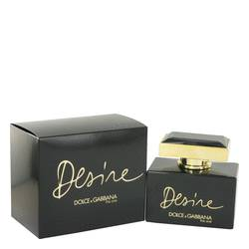

# Perfume for Women - 50ml

Key Features

* Gender: For Women
* Size: 100ml
* Long lasting
* Beautiful fragrance